Laiba Mudassar
Sp26-bcs-021
LAB MID

QUESTION NO 1 MS EXCEL

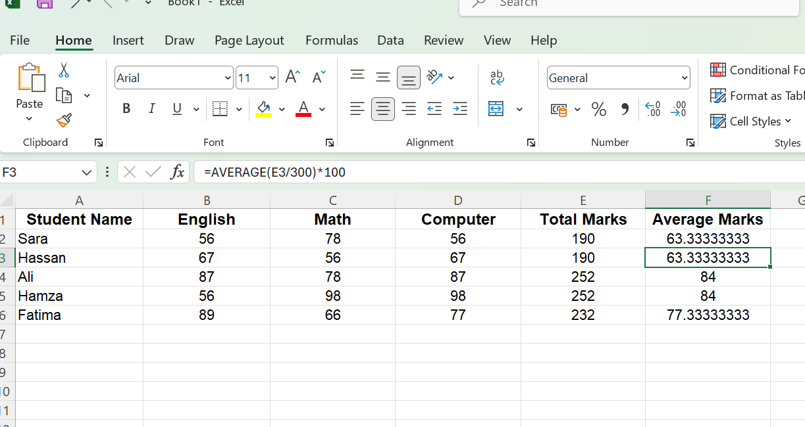

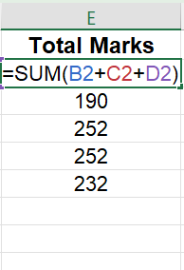
Sum formula

Average Formula

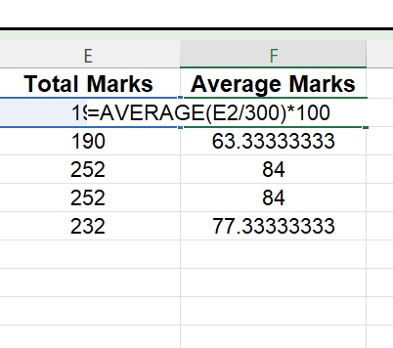

Question no 2 raptor

Algorithm
- First take input symbol in which adding prompt to take marks from users and store in variable marks .
- After use selection box in which in diamond box add condition if marks greater than 50
- On yes side add output box in which write pass
- On no side add output box in which write fail

Flow Chart
PASS RESULT

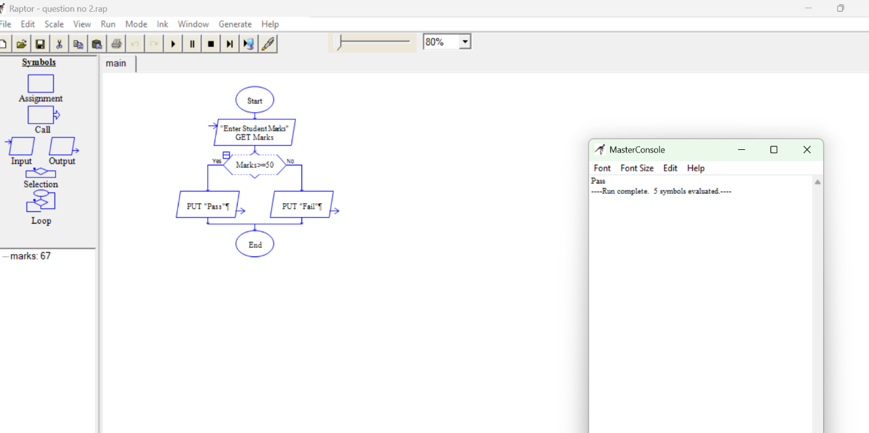

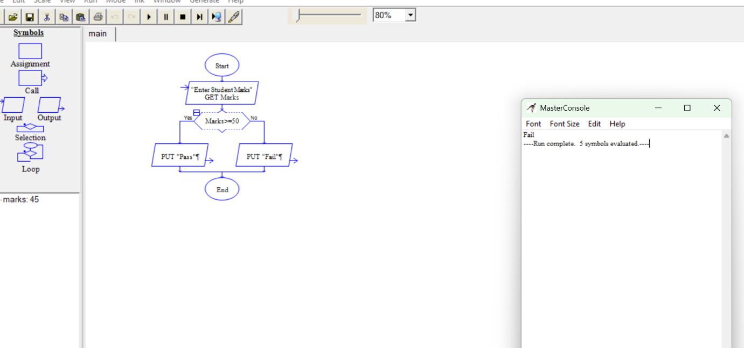
FAIL RESULT

